
Beechen Hall, Wildfell Close, Walderslade, Chatham, Kent. ME5 9RU
01634 861237
clerk@boxleyparishcouncil.gov.uk
Clerk: Daniela Baylis
Assistant Clerk: Heidi Pearson
Finance Assistant: Nichola Carter

www.boxleyparishcouncil.gov.uk

A G E N D A

There will be meeting of a Woodland Management Committee on Wednesday 23 February 2026 at Beechen Hall, Wildfell Close, Walderslade, ME5 9RU at 6.30pm

- Apologies and Absences
To receive and accept apologies for absence.

- Declaration of Interests, Dispensations, Predetermination or Lobbying
Members are required to declare interests, dispensations, predetermination or lobbying on items on this agenda. Members are reminded that changes to the Register of Interests should be notified to the Clerk.

- Motion to Exclude the Press and Public from the Meeting for Items in the Confidential Section.

- Minutes of the Meeting held on 26 November 2025 (Pages 3-4)

- Matters Arising from the Minutes (Pages 4-5)

- Outstanding Insurance Issue (Page 5)

- Budget 26/27 – Update (Pages 5-7)

- Accident/Near Miss Reporting & Accident Book Quarterly Review
(to P/E 31st Dec)

- Walderslade Woodlands
  - Interim Work Plan – Volunteer Group (verbal update)
  - Revised Management Plan (document circulated separately)
  - Review of Risk Assessments (documents circulated separately)
  - Review of Health & Safety Policy (Pages 8-11)
  - Two Wheeled Tractor – Update (verbal update)
  - Volunteer Training & Equipment Needs (Page 12)
  - Volunteer Group – Verbal Report

- Procedure - Overlapping Issues between Committees

- Impton Lane Open Space (Page 12)

- Weavering Diamond Jubilee Orchard (Page 12)

- Franklin Drive (Page 12)

- Beechen Hall (Page 12)

- St Mary and All Saints Church Boxley (Pages 12-16)

- Resident Engagement

- Items for Next Agenda – DECISION
Requests for items to be included on the next agenda.

- Next Meeting
Date to be decided.

CONFIDENTIAL SECTION
Daniela Baylis
Daniela Baylis
Clerk to Boxley Parish Council Date: 18 February 2026

Supporting agenda papers for the Woodland Committee Meeting to be held on 23 February 2026. The Chairman will assume that these have been read prior to the meeting.

Councillors wishing to suggest changes to any policy or procedure document in this agenda should notify the office, in writing, at least three working days in advance of the meeting to allow details to be circulated at the meeting (or in advance if particularly contentious).

Item 4. Minutes of the meeting held on 26 November 2025

W

Minutes of the Boxley Parish Council Woodland Management Committee held at Beechen Hall, Wildfell Close, Walderslade at 7pm on 26th November 2025

Councillors Present: Cllrs V Jones (Chair), P McLean, A Brindle and I Davies along with Patrick Fox, Rob Burrows and Derek Price.
Minutes – Cllr V Jones

Cllr Jones welcomed Derek Price who wishes to join the committee.

- Apologies and absences
Cllrs Thompson, Zand and Dines

- Declaration of Interests, Dispensations, Predetermination and Lobbying
None.

- Motion to exclude the press and public from the meeting for all items in the Confidential Section.
All items to be taken in public. Proposed by Cllr Jones and seconded by Cllr McLean.

- Minutes of the meeting held on 1st October 2025
Agreed and signed by the Chair.

- Matters Arising (from 1st October)
AP1 Cllr Zand to circulate accident book review flow chart.
AP2 Clerk to add accident book quarterly reviews to future agendas.
AP3 Cllr Jones attended IT/AI training arranged by Cllr Zand. Clerk and Assistant Clerk to agree an alternative date.

- Walderslade Woodland
6.1 No update available regarding the outstanding claim. Cllr Jones thanked WWG for their assistance with updating the asset register and apologised that work was suspended whilst insurance cover was being negotiated. WWG’s constitution has been dissolved, and they are no longer deemed a separate group. They now come under the umbrella of BPC. All activities and tools, except the two wheeled tractor, have been added to BPC’s Ansvar insurance policy, plus public liability for the land is now included. This gave a saving of £781 on a previous quote obtained. Partick agreed to look into the status of the tractor as to whether it should be registered for road use or not. He will liaise with Cllr Jones regarding this. It was noted that the new policy only allows for trees to be felled up to 350mm.
Rob Burrows confirmed there are several Risk Assessments in place. He confirmed he would forward these to Cllr Jones for review. Cllr Jones will discuss a Health and Safety policy with Neil Coombs.
Action Point 1: Patrick Fox to investigate the status of the tractor
Action Point 2: Rob Burrows to forward all Risk Assessments to Cllr Jones
Action Point 3: Cllr Jones to discuss H&S policy with Neil Coombs

6.2 Revised Management Plan should be with Cllr Jones by mid-December. In the meantime, WWG have been issued with an interim workplan. Rob Burrows stated he only received the interim workplan with today’s agenda. Cllr Jones stated it was sent some weeks ago and she will check the date of the email.
Action Point 4: Cllr Jones to confirm date interim workplan sent to WWG.

6.3 It was noted that all expenses must be supported by receipts. Prior approval is not necessary for incidental expenses/one transaction under £100. Over this amount, approval must be sought in advance from the Clerk and details copied to Cllr Jones. Items for inclusion on the asset register will be added by the Clerk. It is preferable to store parish information on OneDrive visible to all Cllrs.

6.4 Item covered under 6.3

6.5 Cllr Jones confirmed that chainsaw and brushcutter refresher training is due by November 2026. Rob Burrows asked if trained operators could train others in the group. Cllr Jones stated this is not an acceptable practice and all volunteers wishing to use chainsaws/brushcutters etc. will need to attend an appropriate course. Rob Burrows stated he has a licence to allow him to use a pole saw which he will send to Cllr Jones. Cllr Brindle asked where training records will be kept and who will maintain them. Cllr Jones confirmed that she has an excel sheet showing all the training carried out and expiry dates, based on certificates provided to her by the volunteers. Cllr Brindle asked that the information is shared with the Personnel Committee.
Action Point 5: Rob Burrows to forward pole saw certificate to Cllr Jones
Action Point 6: Cllr Jones to share training data with Cllr Akehurst.

6.6 Rob Burrows explained the recent months had been very challenging for all the volunteers, but morale is now picking up. Cllr Jones reiterated that it had been a difficult time starting with the insurance claim then, just as volunteers were about to resume work, activities had to been suspended completely for some weeks due to the expiry of insurance cover for the group. She thanked all volunteers for their help in compiling an asset register which was needed before insurance cover could be arranged.

- Budget 2026/27
Cllrs agreed more detail required. Cllr Jones to meet with the Clerk.
Action Point 7: Cllr Jones to meet with the Clerk.

- Impton Lane Open Space
No action for this committee.

- Weavering Diamond Jubilee Orchard
It was identified on the Parish Tour that the hedge adjacent to Penshurst Place needs cutting back. Quote needed.
Action Point 7: Cllr Jones to meet with the Clerk.

- Franklin Drive
No action for this committee

- Beechen Hall
Contractors have removed the Oak’s failed limbs. The tree has been left in situ as standing deadwood which is a valuable habitat.

- Resident Engagement
Tree queries received from residents in Longwood, Olivine and Ploughmans. Hoods will carry out inspections and report back to the Clerk. In future, all tree concerns raised by residents will be inspected by Hoods. Cllr Jones to be copied in on all correspondence. Cllr Jones to clarify policy for tree work with the Clerk.
Action Point 9: Cllr Jones to check policy with the Clerk.

- Items for Next Agenda
Date to be circulated.

- Next Meeting
Date to be circulated.

Item 5: Matters Arising

W

Action Point 1: Patrick Fox to investigate the status of the tractor
Action Point 2: Rob Burrows to forward all Risk Assessments to Cllr Jones
Action Point 3: Cllr Jones to discuss H&S policy with Neil Coombs
Action Point 4: Cllr Jones to confirm date interim workplan sent to WWG.
Action Point 5: Rob Burrows to forward pole saw certificate to Cllr Jones
Action Point 6: Cllr Jones to share training data with Cllr Akehurst.
Action Point 7: Cllr Jones to meet with the Clerk re budget.
Action Point 8: Cllr Jones to meet with the Clerk re WDJO.
Action Point 9: Cllr Jones to check policy with the Clerk.

Item 6. Outstanding Insurance Issue – 10 June 2025

W

Last email received from the Zurich insurance on 25 October 2025

Thank you for your email.

We wouldn’t be able to give you a settlement figure at this stage I’m afraid. Once we admit a breach, the claimant will need to be assessed by our independent medical expert and they will provide us with a report suggesting the extent of the injury and any scarring etc.

When we receive the report, we will then make the claimant an offer which will be 50% of the amount we value the claim at.

Our current reserve on this claim is £4582 but this is our estimate without medical evidence. This will be reviewed once the report is received.

If you have any queries, please contact me on 0800 917 7207 or email zmflc@uk.zurich.com quoting the reference number above.

Kind Regards

Sarah Samios
Claims Handler – Housing and Charities Team – Casualty Claims

Item 7 – Budget 26/27 update

W

Below is the budget for the Woodland Management Committee as agreed at the Parish Council meeting on the 19th January 2026. It now includes some budget for maintenance of trees in other areas.
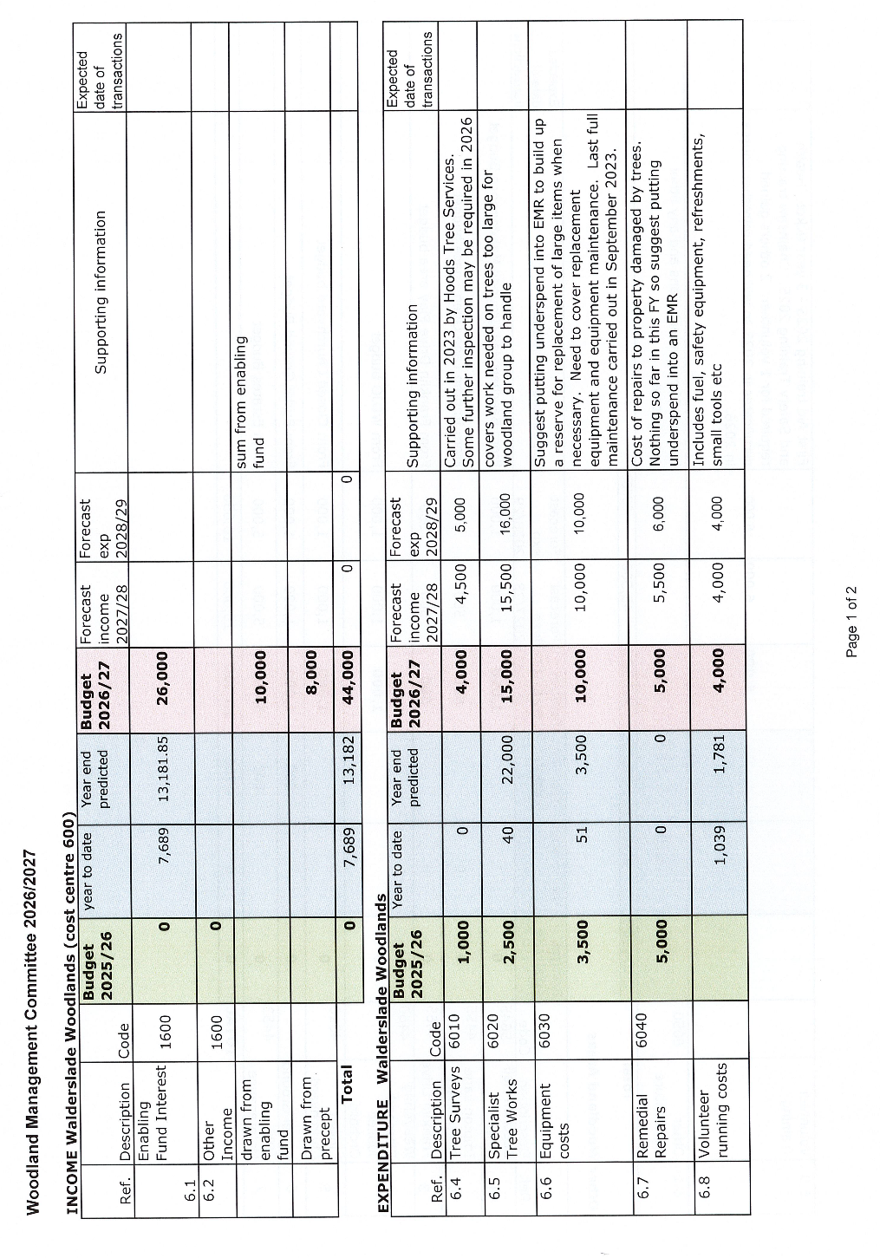
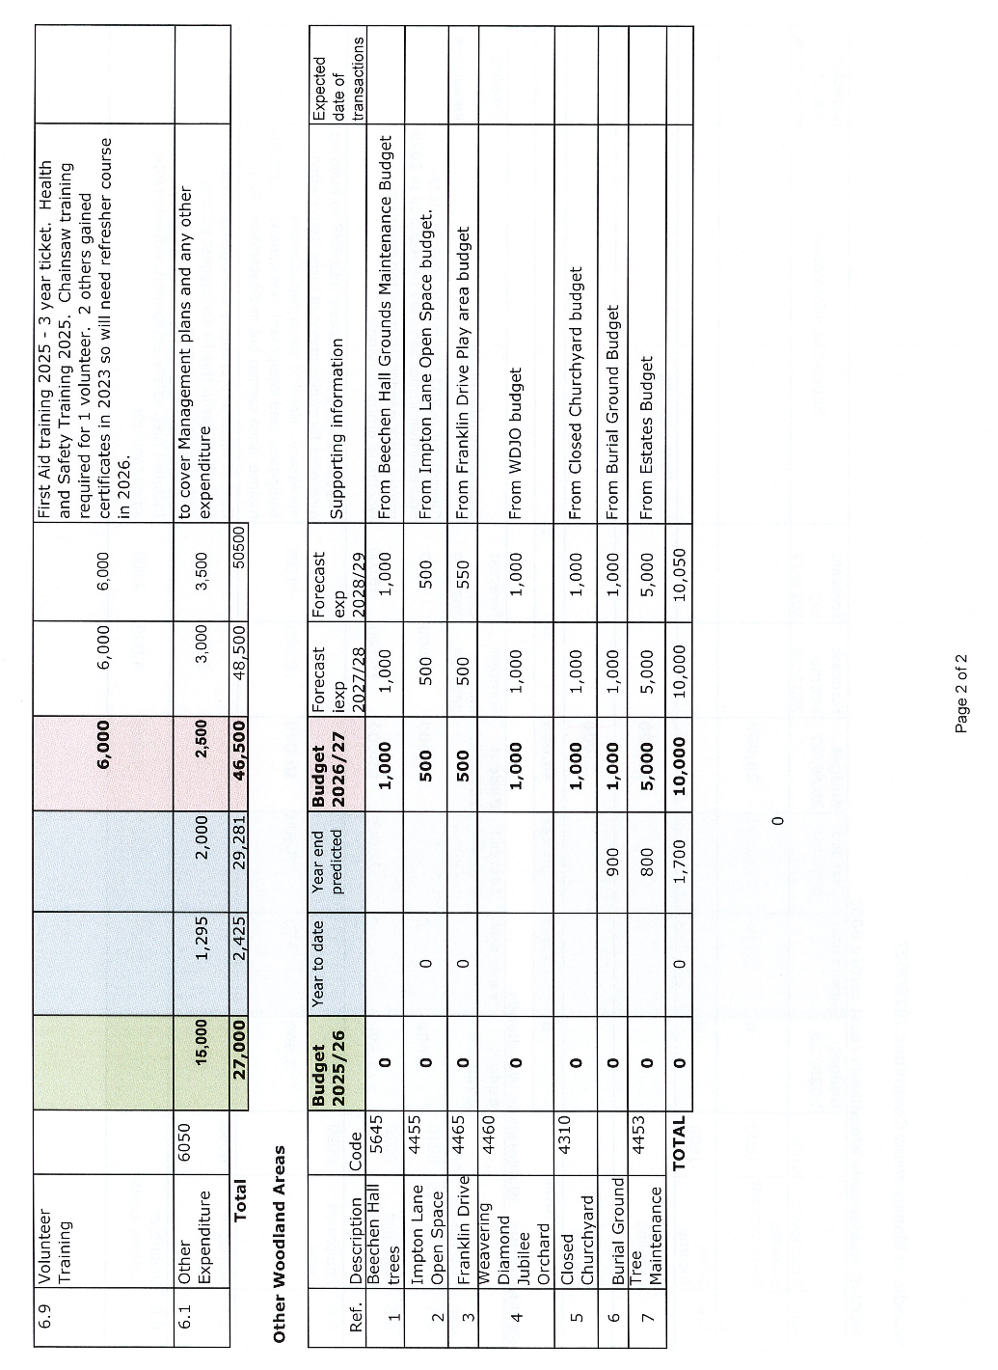

Item 8 – Accident/Near Miss Reporting & Accident Book Quarterly Reporting

W

All accidents and near misses must be reported to the office using the report forms.

9: Walderslade Woodlands

9.1 Interim Work Plan – Volunteer Group (verbal update)

W

Verbal update to be given at the meeting.

9.2 Revised Management Plan (document circulated)

W

Circulated separately.

9.3 Review of Risk Assessments (documents circulated)

W

Documents circulated separately.

9.4 Review of Health & Safety Policy

W



Volunteer Woodland Group Health & Safety Policy
(Aligned with UK HSE & FISA guidance)

Statement of Intent

Boxley Parish Council is committed to ensuring, so far as is reasonably practicable, the health, safety and welfare of all volunteers and members of the public involved in woodland management activities.

All operations will be carried out in accordance with:
- Health and Safety at Work etc. Act 1974
- Management of Health & Safety at Work Regulations 1999
- Provision and Use of Work Equipment Regulations 1998 (PUWER)
- Personal Protective Equipment at Work Regulations 1992 (as amended)
- HSE AFAG guidance
- Forestry Industry Safety Accord (FISA) guidance

Scope

This policy applies to all volunteer activities involving:
- Chainsaws
- Brushcutters
- Strimmers
- Associated woodland management tasks

Key Principles (FISA-Aligned)

- Only trained and competent people operate machinery
- Suitable PPE is always worn
- A site-specific risk assessment is completed
- Emergency arrangements are in place
- Safe working distances are maintained
- Lone working with chainsaws is prohibited

Training & Competence

Chainsaws
Must hold relevant certification appropriate to the task, e.g.:
- NPTC / LANTRA chainsaw maintenance & cross cutting
- Felling (where applicable)
Plus:
- Forestry First Aid +F (or +F equivalent) on site
- Evidence of competence recorded by the Parish Council

Uncertificated volunteers may only assist in non-chainsaw tasks at a safe distance.

Brushcutters & Strimmers
Operators must have:
- LANTRA / NPTC certification or
- Recorded in-house training and competence assessment

Personal Protective Equipment (PPE)

Chainsaw PPE (to EN standards)
- Safety helmet (EN 397) with visor (EN 1731)
- Ear protection (EN 352)
- Chainsaw trousers (EN 381-5)
- Chainsaw boots (EN ISO 17249)
- Chainsaw gloves (EN 381-7)
- Non-snag outer clothing

Brushcutter / Strimmer PPE
- Helmet where risk from overhead hazards
- Eye / face protection
- Hearing protection
- Gloves
- Steel toe-capped boots
- Long trousers and sleeves

Hi-vis clothing required where public access exists.

Emergency Planning (FISA Requirement)
Before work starts the group must identify:
- Emergency access point
- Grid reference / What3Words
- Nearest A&E hospital
- Mobile signal availability
- Who is the trained first aider
- Location of first aid kit & bleed kit
- Fire extinguisher (where fuel and machinery are used)

Safe Working Distances

Chainsaws
Minimum 2 tree lengths

Brushcutters / Strimmers
Minimum 15 metres
Public exclusion zones must be maintained.

Fuel & Fire Safety
- Use approved fuel containers
- Refuel at least 3 metres from ignition source
- Engine off and cool before refuelling
- Spill kit available
- No smoking

Equipment Safety & PUWER Compliance
All equipment must be:
- Suitable for the task
- Maintained in safe condition
- Inspected before use

Defective equipment must be removed from service immediately.
Privately owned equipment must meet the same standards.

Lone Working
Lone working with powered equipment is not permitted.
A minimum of two people must be present, and for chainsaw work a competent second person must be within voice or visual contact.

Accident & Incident Reporting
All accidents, near misses and dangerous occurrences must be:
- Recorded in the accident book
- Reported to the Parish Council
- Investigated where required
RIDDOR reporting will be carried out by the Parish Council where applicable.

Monitoring & Review
This document will be reviewed:
- Annually
- After any incident
- Following changes in HSE or FISA guidance

TOOLBOX TALK CHECKLIST
(To be completed at the start of every session)

Site & Task Details

☐ Site location confirmed
☐ Today’s tasks explained
☐ Site-specific risk assessment reviewed

Emergency Arrangements

☐ Emergency access point identified
☐ Grid reference / What3Words shared
☐ Nearest hospital confirmed
☐ First aider identified
☐ First aid kit checked
☐ Emergency contact method available

Personnel & Competence

☐ All volunteers signed in
☐ Operators confirmed as trained & authorised
☐ Visitors / new volunteers briefed

PPE Check

☐ Correct PPE worn by all
☐ Chainsaw PPE compliant
☐ Hi-vis worn where required

Equipment Checks

☐ Pre-use checks completed
☐ Guards & safety features in place
☐ पर्याप्त fuel & oil stored safely
☐ Defective equipment removed

Work Area Safety

☐ Safe working distances explained
☐ Exclusion zones established
☐ Public access managed
☐ Overhead & ground hazards identified
☐ Weather conditions suitable

Manual Handling & Welfare

☐ Team lifting for heavy items
☐ Drinking water available
☐ Fatigue / breaks discussed

Environmental Considerations

☐ Wildlife / protected habitats considered
☐ Arisings & brash management agreed

Final Briefing
☐ Stop work authority (anyone can stop unsafe work)
☐ Communication method agreed
☐ End-of-session check-out procedure

Supervisor Name: ……………………………………………………………….

Signature:…………………………………………………………………………….

Date: ………………………………………………………………………………….

9.5 Two Wheeled Tractor – Verbal Update

W

Item 9.6 Volunteer Training and Equipment Needs

W

Training on Brush cutters and strimmers has been requested. 2 new strimmers have been requested.

Item 9.7 Volunteer Reports – Verbal Update

W

Item 10: Procedure - Overlapping Issues between Committees

W

Item 11. Impton Lane Open Space

W

No report for this Agenda.

Item 12. Weavering Diamond Jubilee Orchard

W

Work has been done on 2 trees. 1 Fallen and 1 causing damage to parked cars.

Item 13. Franklin Drive

W

No report for this Agenda.

Item 14. Beechen Hall

W

No report for this Agenda

Item 15. St Mary and All Saints Church - Boxley Village

W

The required tree work was carried out on the 22nd December 2025 in the Parish Council Burial Ground.

The tree report for the Closed churchyard and village green is below.
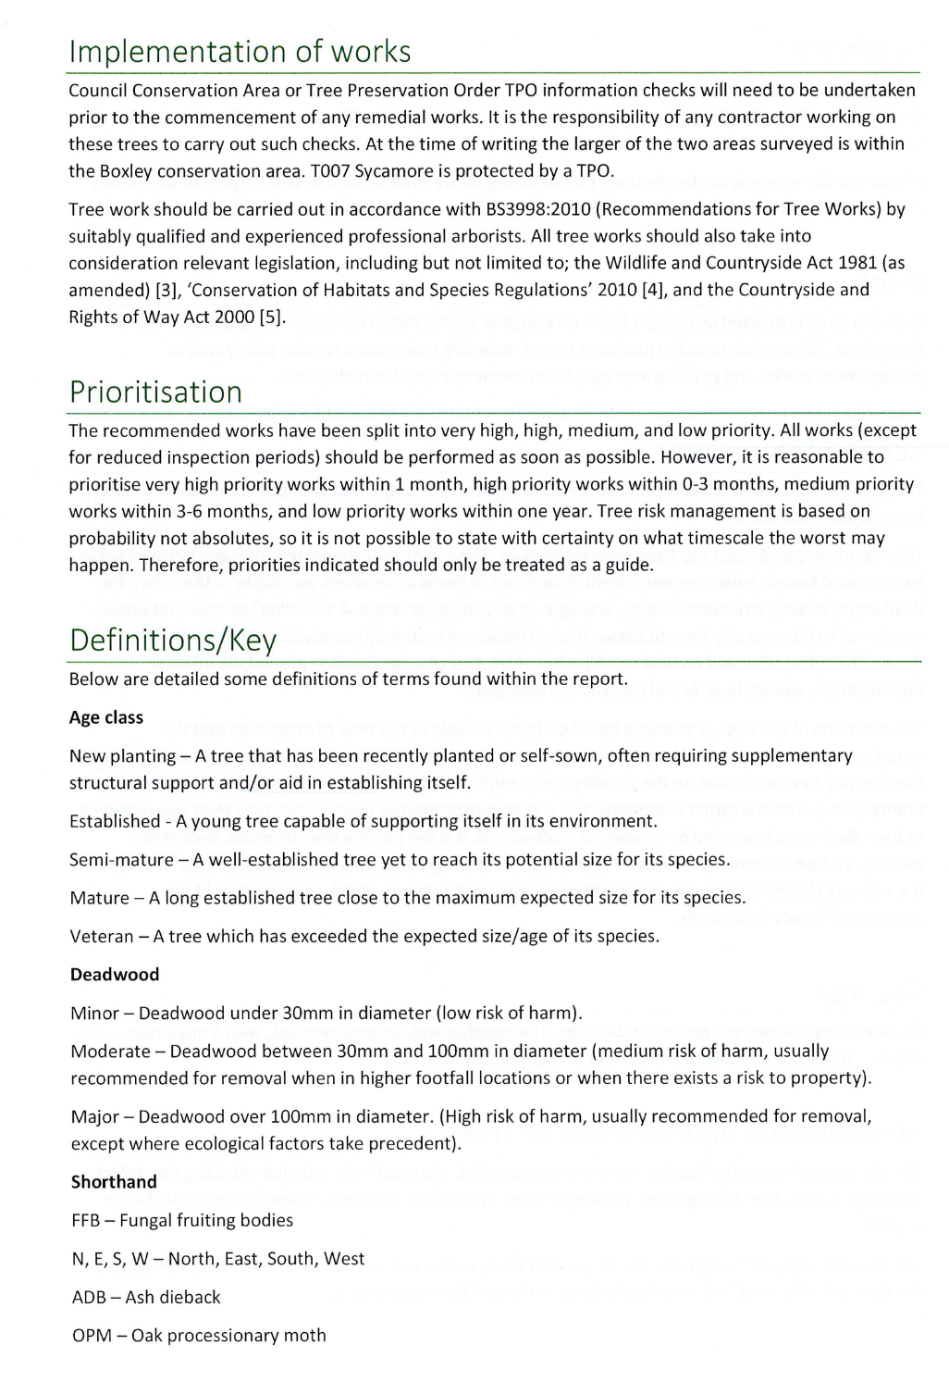
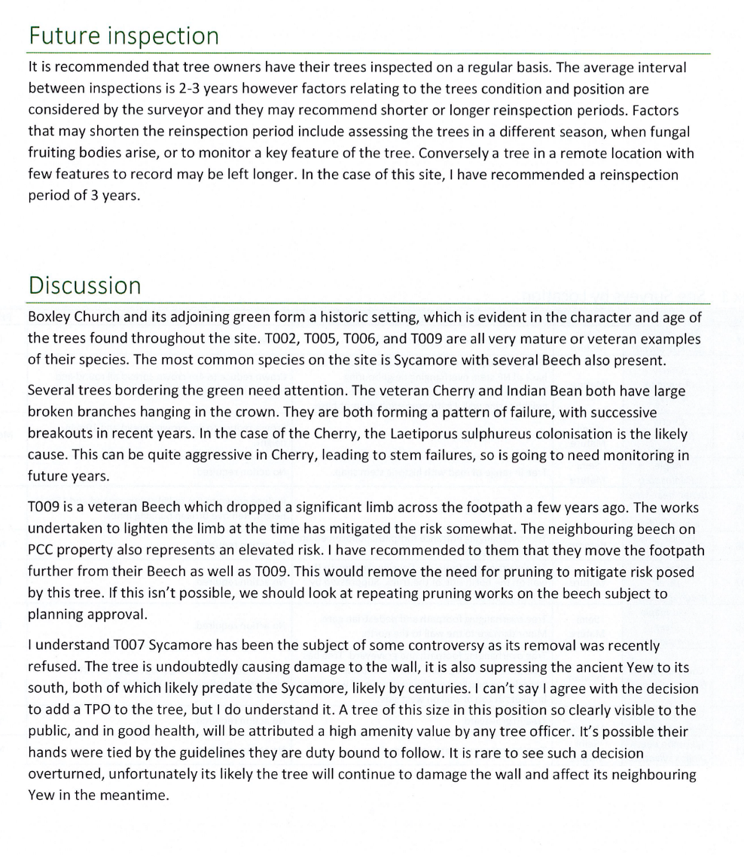

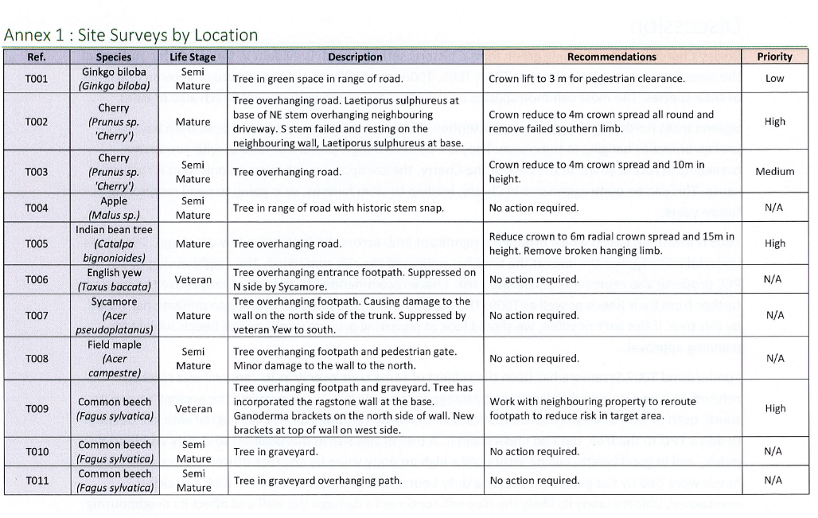
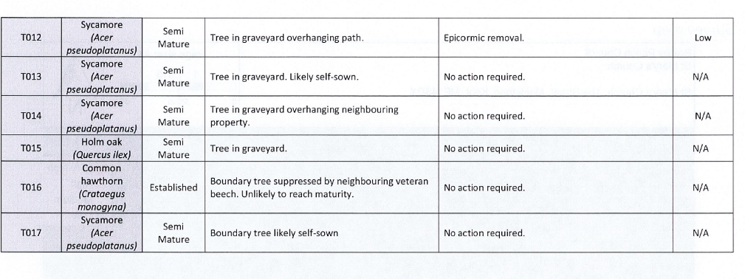

The following is the requested quotation for the high and mediums risk tree work.



